# Report on the realisation of work package “RF Pulsed Power Amplifier”

By Slawomir Gruszczynski PhD., Jakub Sorocki MSc. Eng., AGH University of Science and Technology, Krakow, Poland

Kraków, May 2017, rev. 2

Work Package “RF Pulsed Power Amplifier”

Description

For the product components “ADS-B vehicle transponder” and “MODE-S interrogator” a power amplifier is needed. Investigation has shown that it is not possible to buy a suitable amplifier from stock, which is fulfilling all the requirements. In this package research shall be done to select the best suitable components for a RF power amplifier. The amplifier shall be able to work in pulsed mode for efficient PPM amplification. It shall be designed to be used as part of an ADS-B vehicle transponder, so that small size and low power consumption are important. It may also later be used in a portable, battery powered aircraft transponder. It shall be possible to connect the amplifier to the same antenna that is used for reception, so a RX/TX switch solution needs to be integrated.

There are requirements concerning pulse rise and fall times and spectral limits. A laboratory prototype shall be designed and developed and tests performed concerning compliance to requirements. On top of this reference design a miniature implementation shall be approached.

Requirements:

Frequency range: 1030-1090 MHz

Max. duty cycle: 2%

Modulation: Pulse modulation

Spectrum Limits: As described in ED-73E

Input power: 0 dBm at 50ohm

Output power: 20 W peak

Input voltage: 12-14 V DC

Output

Output shall be a reference prototype of the RF power amplifier. Measurements shall be performed and a report shall be generated to show performance and compliance to requirements. Additional a miniaturized version shall be produced and compared against the reference implementation.

Developed Front-End Module

General Overview

A block diagram of the proposed realisation of the front-end module is shown in Fig.1. In order to meet the design requirements, two stage power amplifier has been proposed in Tx path to ensure Tx output power in combination with two stage power switch to allow usage of single antenna for Rx/Tx as well as to ensure appropriate isolation of Tx path from Rx path.

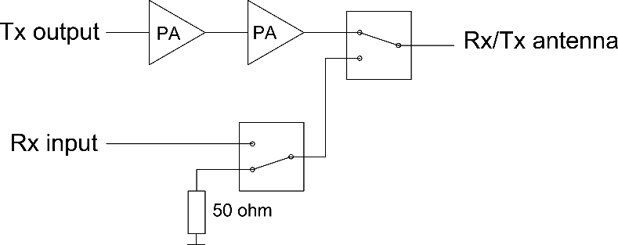

Fig. 1 Block diagram of the front-end module

In the subsequent paragraphs a detailed description of each sub-module is provided, i.e. 1st and 2nd amplifier stage as well as Rx/Tx switch. Moreover, measurement results are provided for manufactured RF power amplification stage demonstrators as well as for the entire front-end module.

RF Amplifier, 1st stage, input *Pin_max* = 0 dBm, output *Pout_min* = 30 dBm

First stage of the RF power amplifier has been designed to provide at least 30 dB of gain with output power Pout_min = 30 dBm @ 1050 MHz. For that purpose, the *Skyworks SKY65111* ISM 600–1100 MHz Band, 2 Watt InGaP HBT Power Amplifier IC has been selected and used. Schematic diagram of the designed amplifier is shown in Fig. 2 while PCB layout is presented in Fig. 3. Electrical specification of the developed sub-module is provided in Table 1.

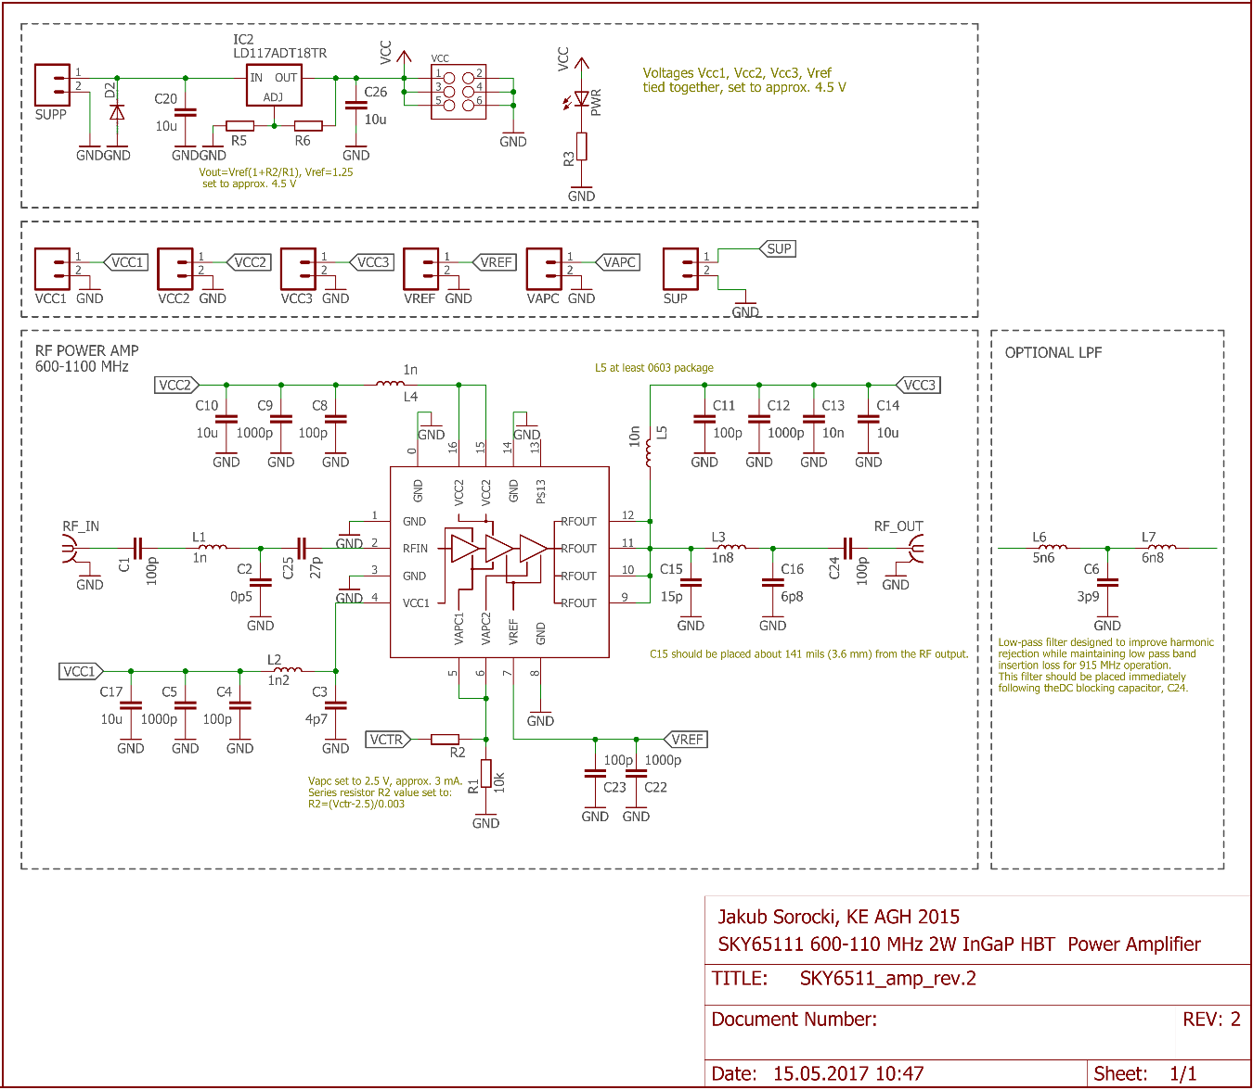

Fig. 2 Schematic of the developed *Skyworks SKY6511* based RF power amplifier.

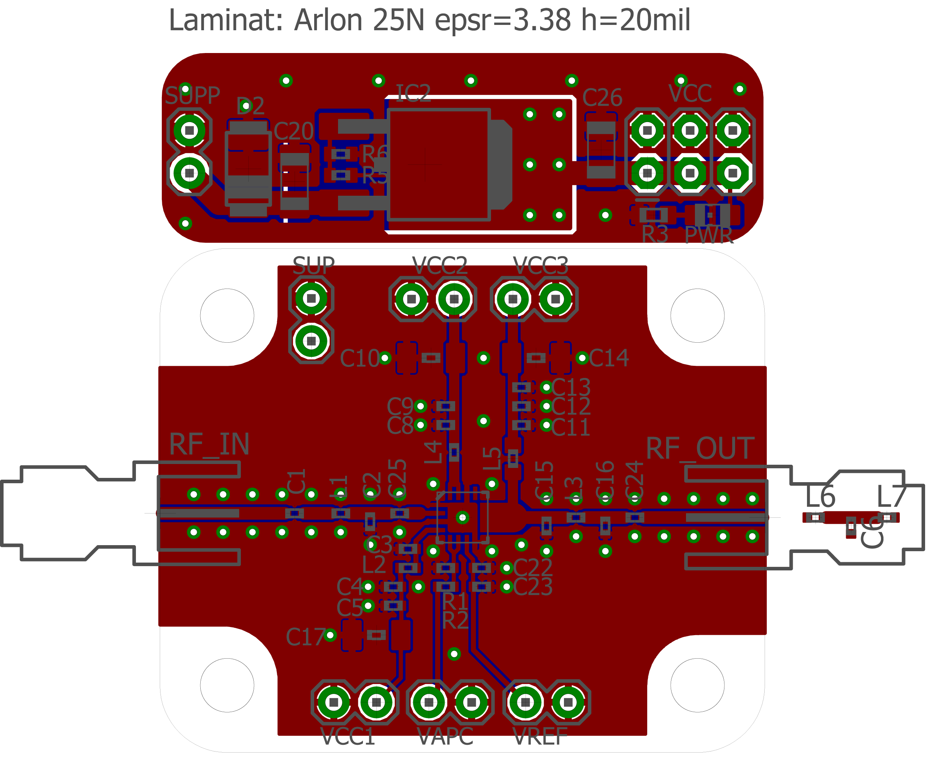

Fig. 3 Layout of the developed *Skyworks SKY6511* based RF power amplifier, designed for testing and verification purpose (not in scale).

|  |  |  |  |
| --- | --- | --- | --- |
| **Parameter** | **Min** | **Nom** | **Max** |
| Supply voltage *Vsup* | 5.5 V DC | 12 V DC | 15 V DC |
| Control voltage *Vctr*, ON state (set by selection of R2) | 2.5 V DC | - | *Vsup* |
| Control voltage *Vctr*,  OFF state | GND/O.C. | - | 2 V DC |
| Quiescent current *IQ,*  ON state, no RF power | - | 150 mA DC | - |
| Active state current *Iact,*  ON state*, PRFin* = 0 dBm | - | 500 mA DC | - |

Table 1. Electrical specification of the 1st stage RF power amplifier.

In order to meet the requirements regarding power supply voltage (*Vsup* = 12 V DC), the module has been equipped with one voltage regulator to provide 4.5 V DC for the IC. The IC internal voltages *VCC*1, *VCC*2, *VCC*3 and *VREF* can be tied together and connected to the voltage regulator output. The amplifier has also been equipped with ON/OFF functionality. The control voltage can be set up for a given control logic by appropriate selection of resistor R2 (*Vapc* pin should be 2.5 V DC for ON state). The RF input and output paths must be 50 Ω transmission lines.

RF Amplifier, 2nd stage, input *Pin_max* = 30 dBm, output *Pout_min* = 43 dBm

Second stage of the RF power amplifier has been design to provide at least 13 dB of gain with output power Pout_min = 43 dBm @ 1050 MHz allowing the amplification stage to meet the requirement. For that purpose, an A class amplifier has been designed using discrete *NXP MRFE6VS25* 1.8--2000 MHz, 25 W, 50 V wideband RF power LDMOS transistor in common source configuration. Schematic diagram of the designed amplifier is shown in Fig. 4 while PCB layout is presented in Fig. 5. Electrical specification of the developed sub-module is provided in Table 2.

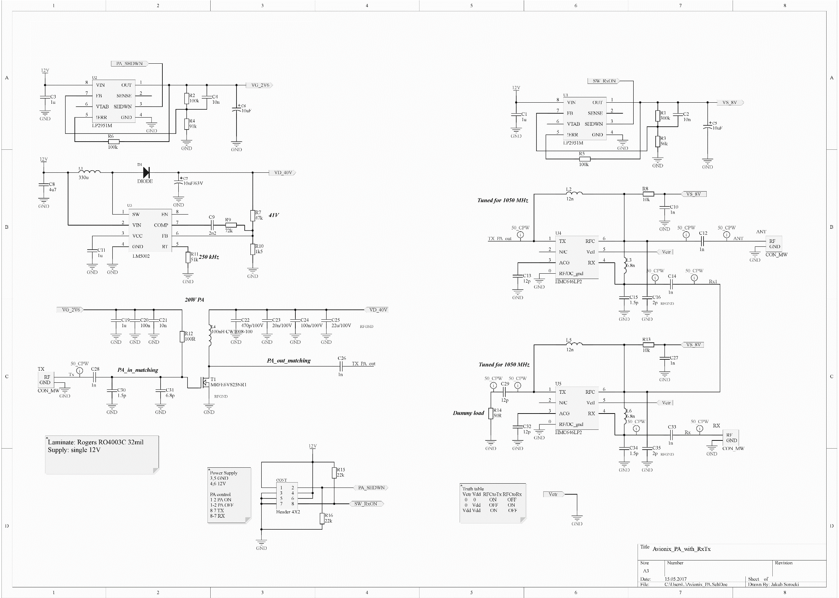

Fig. 4 Schematic of the developed *NXP MRFE6VS25* based RF power amplifier.

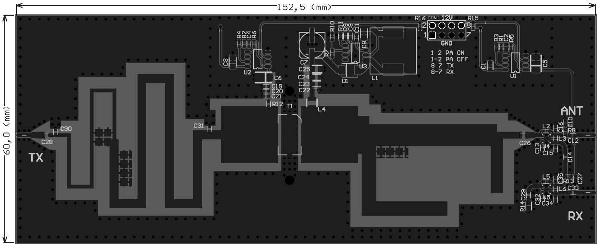

Fig. 5 Layout of the developed *NXP MRFE6VS25* based RF power amplifier (not in scale).

|  |  |  |  |
| --- | --- | --- | --- |
| **Parameter** | **Min** | **Nom** | **Max** |
| Supply voltage *Vsup* | 10 V DC | 12 V DC | 14 V DC |
| Control voltage *Vshdwn*, ON state | GND | - | 0.7 V DC |
| Control voltage *Vshdwn*, OFF state | 2 V DC | O.C. | *Vsup* |
| Quiescent current *IQ,* OFF state  *IQ,* OFF state | - | RF *Pin* 7 mA DC  RF *Pin* 20 mA DC | - |
| Active state current *IQ,* ON state  *Iact*, ON state | - | RF *Pin* off 90 mA DC  RF *Pin* on 170 mA DC | - |

Table 2. Electrical specification of the 2nd stage of the RF power amplifier.

In order to meet the requirements regarding power supply voltage (*Vsup* = 12 V DC), the module has been equipped with one voltage regulator to provide 8 V DC for the ICs. The amplifier has also been equipped with ON/OFF functionality realized using enable input of the gate voltage regulator which when turned off effectively turns off the gate voltage. Since the ON/OFF functionality is realized by means of turning on and off transistor gate DC voltage while drain voltage being present, there is a small quiescent current flowing in OFF state (dependent on whether RF input power is present or not). The ON/OFF time is estimated to be under 360 µs. In order to decrease the ON/OFF time, an external low-power fast switching transistor can be used allowing to turn on and of gate DC voltage.

PCB layout of the amplifier has been developed for manufacturing on 32 mil thick *Rogers RO4003C* microwave laminate having well-defined electrical parameters. The amplifiers` input and output matching circuits being a combination of distributed and lumped elements have been designed and fine-tuned in such a way to provide maximum power on two frequencies simultaneously, i.e. 1030 MHz and 1090 MHz. Additionally, it is important to provide appropriate heat sinking for the RF transistor in order to obtain long-term stable output power.

Rx/Tx switch circuit

The Rx/Tx paths switch circuit allowing for monostatic operation has been designed to withstand at least 46 dBm of transmit power while maintaining low insertion losses as well as to provide at least 40 dB of isolation between Rx and Tx paths @ 1050 MHz. For that purpose, the *Hittite HMC645LP2* 0.1 – 2.1 GHz GaAs MMIC 40W Failsafe Switch IC has been selected and two of such has been used. Schematic diagram of the designed switch is shown in Fig. 6 while PCB layout is presented in Fig. 7. Electrical specification of the developed sub-module is provided in Table 3.

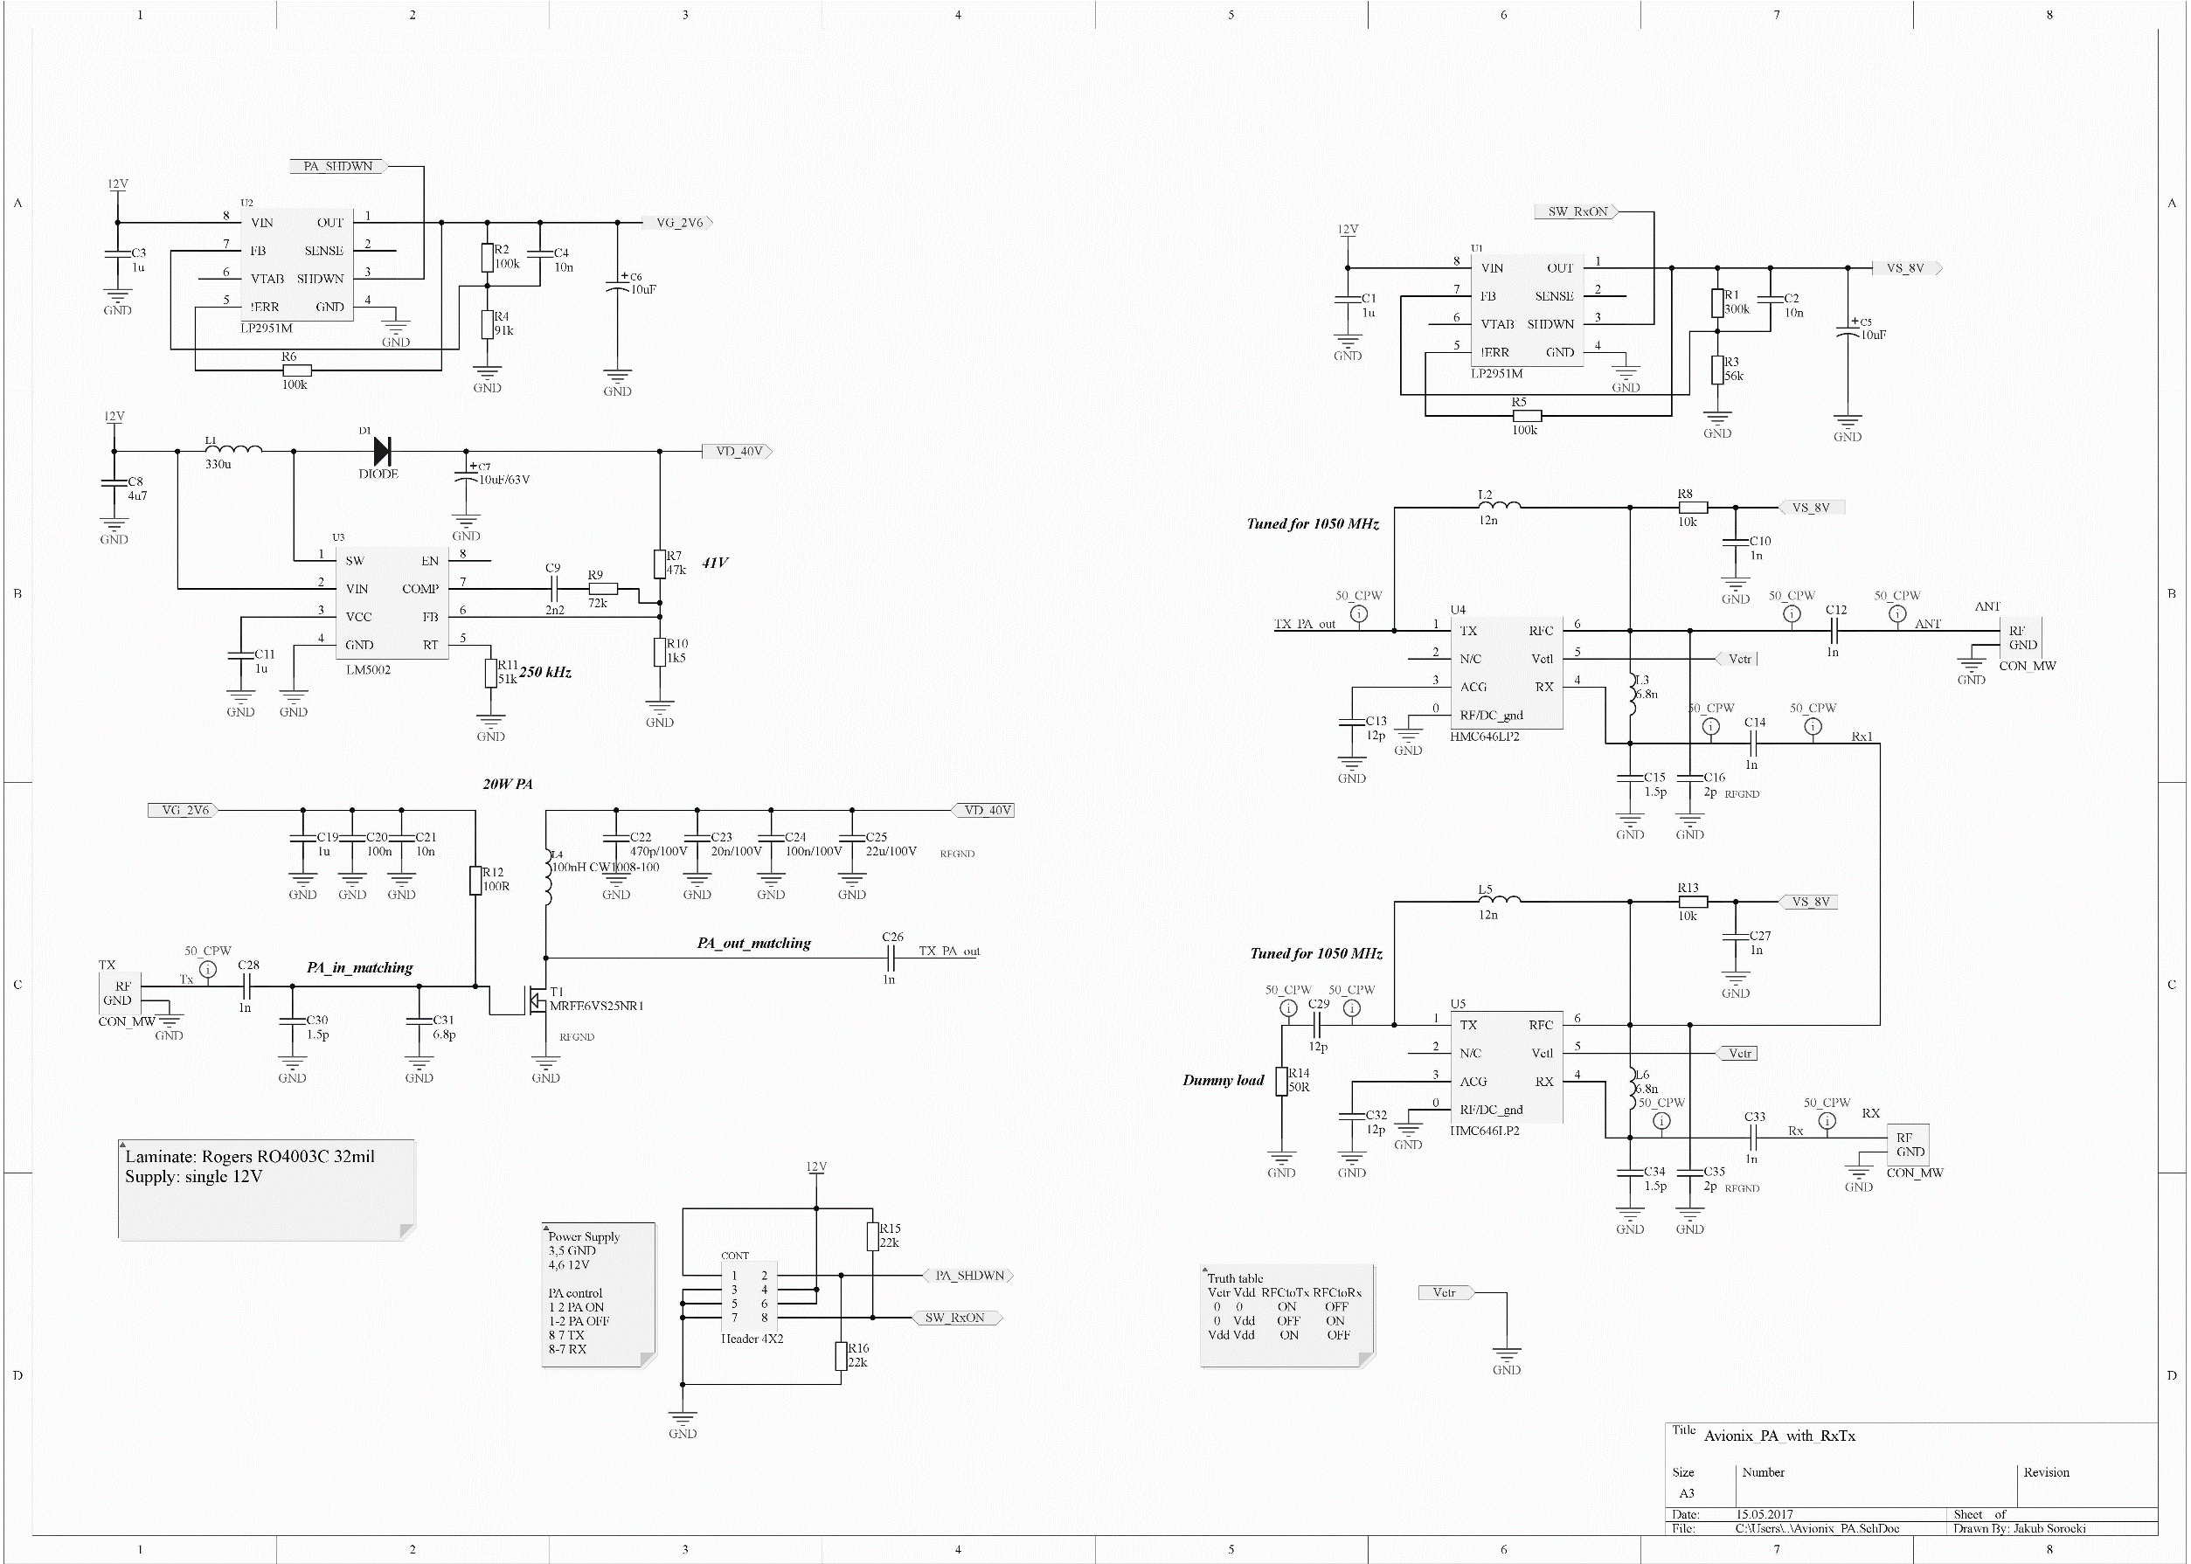



Fig. 6 Schematic of the developed *Hittite HMC645LP2* based Rx/Tx switch circuit.

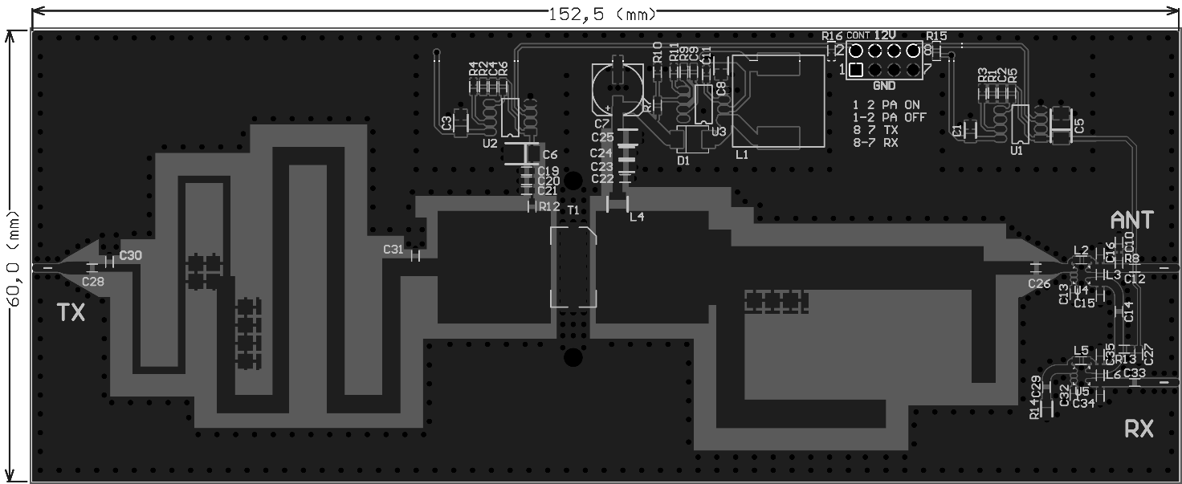

Fig. 7 Layout of the developed *Hittite HMC645LP2* based Rx/Tx switch circuit (not in scale).

|  |  |  |  |
| --- | --- | --- | --- |
| **Parameter** | **Min** | **Nom** | **Max** |
| Supply voltage *Vsup* | 10 V DC | 12 V DC | 14 V DC |
| Control voltage *VSW*, Tx to RFC | 2 V DC | O.C. | *Vsup* |
| Control voltage *VSW*, RFC to Rx | GND | - | 0.7 V DC |

Table 3. Electrical specification of the Rx/Tx switch circuit.

In order to meet the requirements regarding power supply voltage (*Vsup* = 12 V), the module is equipped with one voltage regulator to provide 8 V of voltage and one DC-DC converter to provide 40 V of drain voltage. Since, the single IC does not provide suitable isolation between Rx and Tx paths, two of such ICs have used and connected in such a way that when Tx is connected to RFcommon, the unwanted signal through isolated path is routed to the dummy 50 Ω load. Switching between Rx and Tx paths has been realized using enable input of the voltage regulator and taking advantage of the switch IC truth table including Failsafe functionality. When the regulator is turned off (default state, no signal required), the RFcommon path is connected to Tx, otherwise, the RFcommon is switched to Rx. The switch time is estimated to be under 360 µs. In order to decrease the switch time, an external low-power fast switching transistor can be used allowing to turn on and off supply and control voltages of the switch IC. The switch time of the IC itself is typically 320 ns. The ICs matching circuit is tuned to 1050 MHz to provide minimal losses at both frequencies of interest, i.e. 1030 MHz and 1090 MHz.

RF power amplifier demonstrator - measurement results

The developed RF power amplifier has been manufactured and measured. Low-power 1st stage amplifier on a separate PCB has been used to drive high-power 2nd stage amplifier. For testing purpose, the amplifier was feed with 1% duty cycle pulse modulated RF signal with *Pin* = -1 dBm. A photograph of the manufactured circuits is shown in Fig. 8 while measurement results are shown in Fig. 9 and Fig. 10.

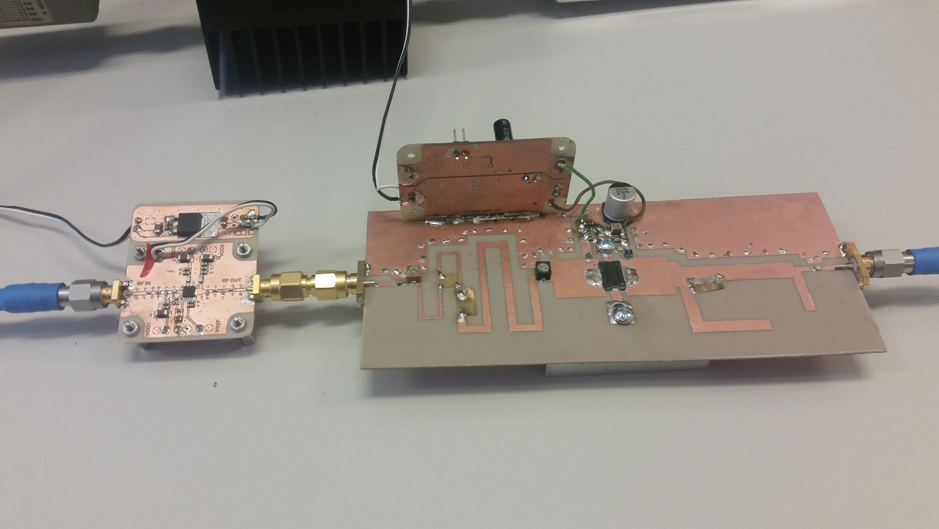

(a)

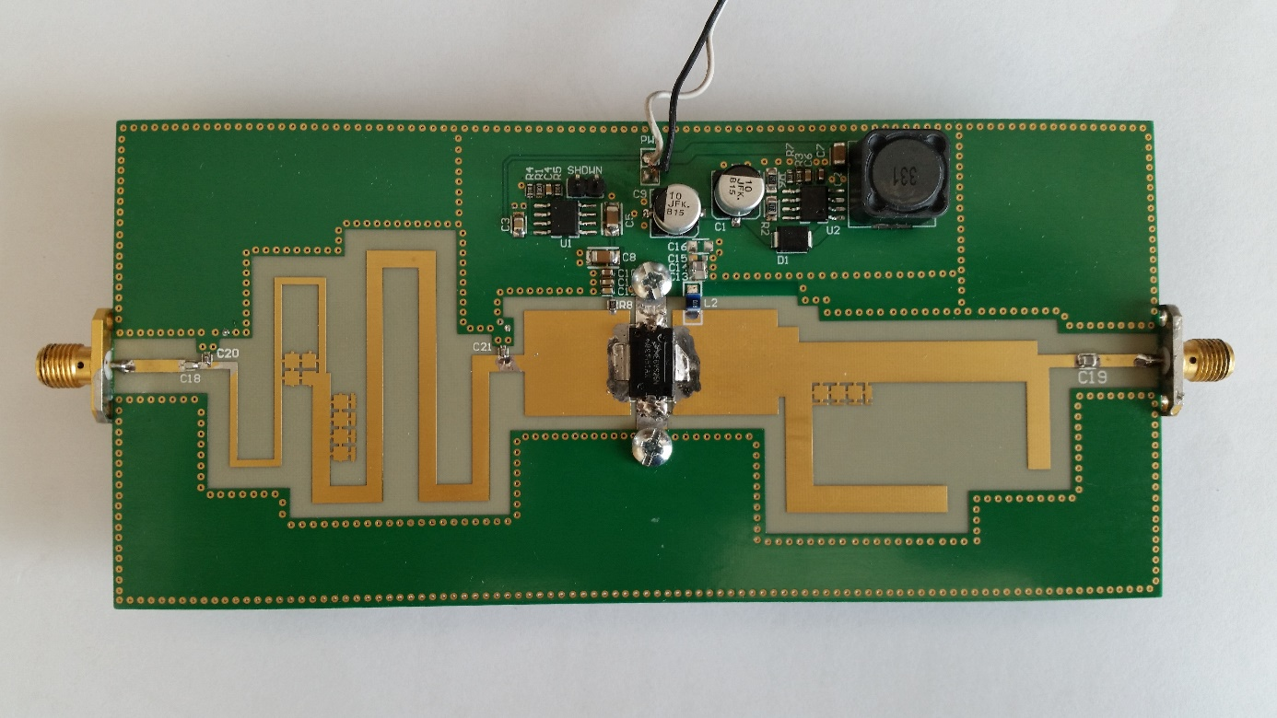

(b)

Fig. 8 Photograph of the manufactured 1st (a) and 2nd (b) stage of the RF power amplifier.

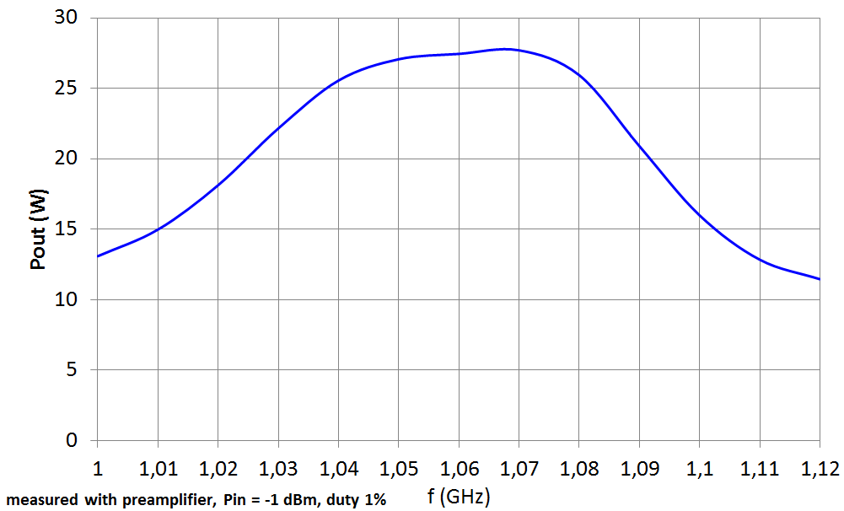

Fig. 9 Measured output power of the amplifier vs. frequency. The 2nd stage amplifier has been driven from the 1 W 1st stage preamplifier with the input power *Pin* = -1 dBm.

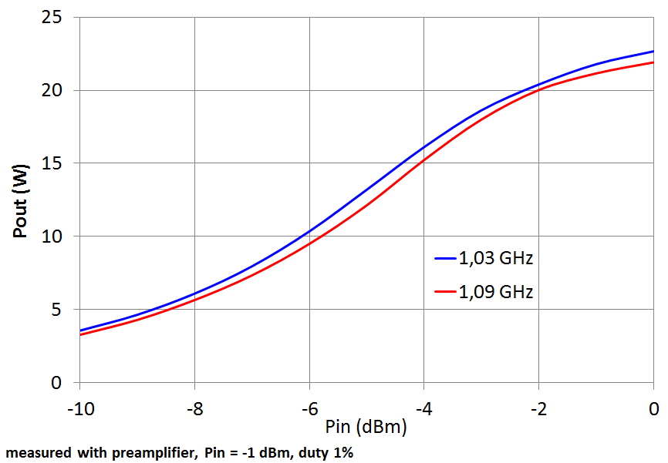

Fig. 10 Measured output power of the amplifier vs. input power for two frequencies of interest. The 2nd stage amplifier has been driven from the 1 W 1st stage preamplifier with the input power *Pin* = -1 dBm.

The developed RF power amplifier has also been tested against nonlinear distortions as specified in the design requirements and it passed the tests at both frequencies. Measured spectrum of the amplified RF signal at 1030 MHz and at 1090 MHz is shown in Fig. 11 and Fig. 12 respectively.

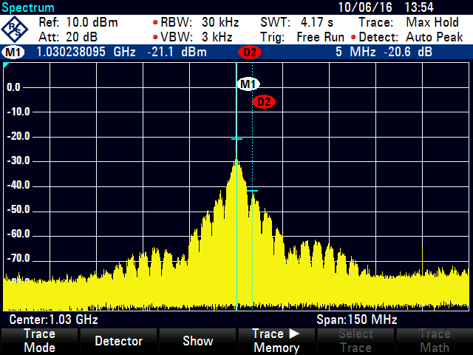

Fig. 11 Output RF signal spectrum measured at 1030 MHz

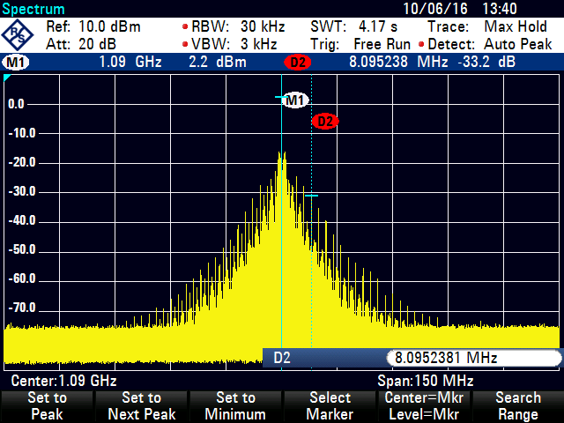

Fig. 12 Output RF signal spectrum measured at 1090 MHz

Front-end module demonstrator - measurement results

The developed front-end module has been manufactured and measured. Low-power 1st stage amplifier on a separate PCB has been used to drive high-power 2nd stage amplifier. Moreover, the Rx/Tx paths switching circuit has been integrated on one PCB with the 2nd stage amplifier. The supply voltage input as well as PA ON/OFF and Rx/Tx control inputs are broken out using IDC style connector whose pin description is provided in Table 4.

|  |  |  |  |  |
| --- | --- | --- | --- | --- |
| **Signal** | **Header** | | **Signal** | **Function** |
| GND | 1 | 2 | *Vshdwn* | PA ON when 1-2 shorted using jumper, otherwise leave unconnected |
| GND | 3 | 4 | *Vsup* | PA & SW supply voltage |
| GND | 5 | 6 | *Vsup* | PA & SW supply voltage |
| GND | 7 | 8 | *VSW* | RX when 7-8 shorted using jumper, otherwise leave unconnected |

Table 4. Connection header description of 2nd stage PA PCB with integrated switch.

For testing purpose, the amplifier has been fed with 1% duty cycle pulse modulated RF signal with *Pin* = 1 dBm. Photographs of the manufactured circuits are shown in Fig. 12 and Fig. 13 while measurement results are presented in Fig. 14 and Fig. 15. The measured output power of the Tx path equals 18.2W @ 1.03 GHz and 24.3W @ 1.09 GHz. The measured insertion losses of the receiving path equals 1.2 dB and the isolation of the receiving output to the antenna equals 49 dB.

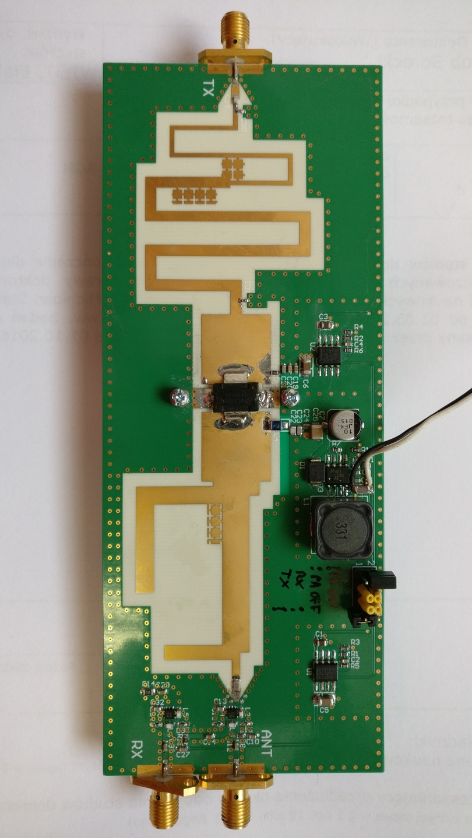

Fig. 12 Photograph of the manufactured 2nd stage RF power amplifier with integrated Rx/Tx switching circuit.

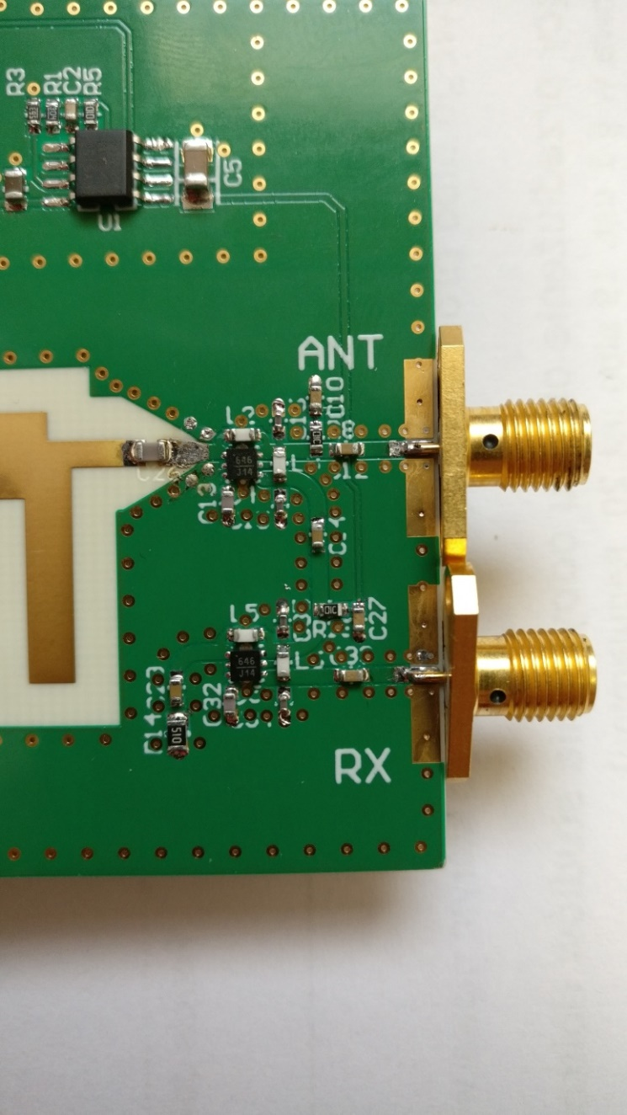

Fig. 13 Close-up picture of the receiving path.

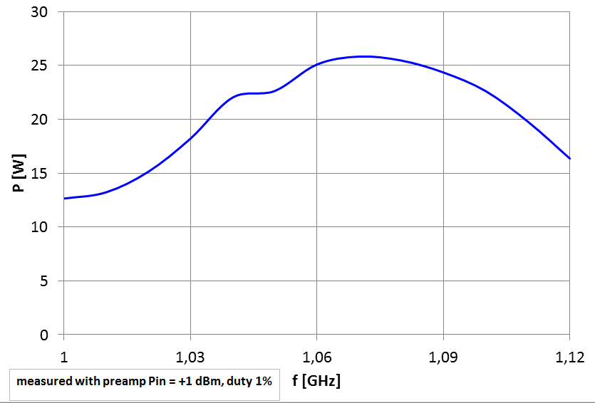

Fig. 14 Measured output power of the Tx path including RF power amplifier and the switch vs. frequency. The 2nd stage amplifier has been driven from the 1 W 1st stage preamplifier with the input power *Pin* = 1 dBm.

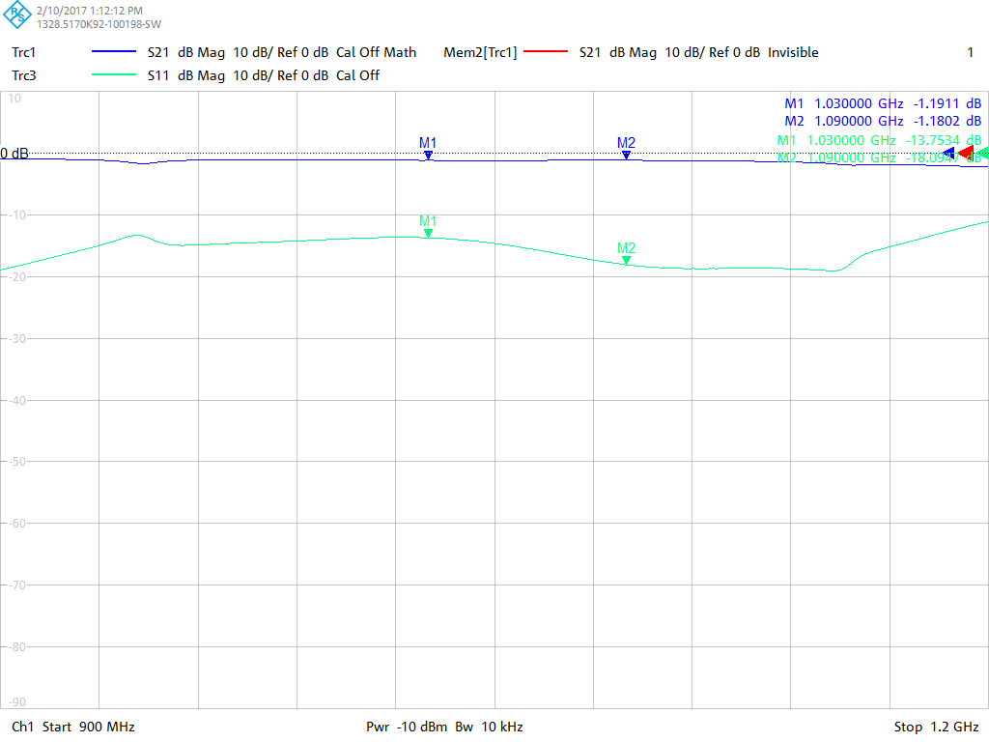

(a)

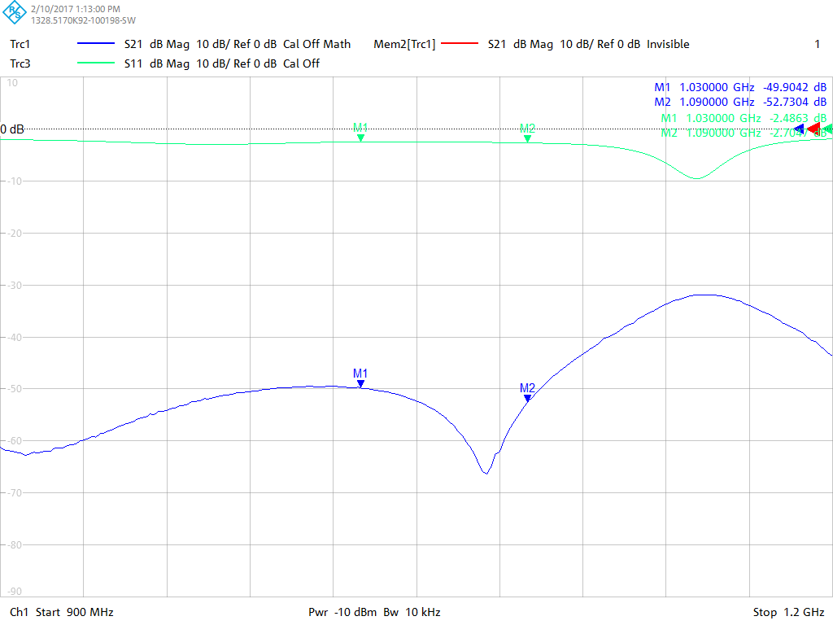

(b)

Fig. 15 Measured Rx path insertion loss (a) and isolation (b).